Swiss Foundation

for
Alpine Research
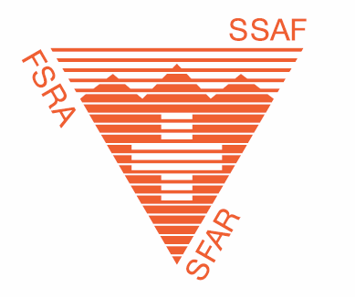

Supporting research which benefits the mountain environment, mountain populations
and mountain sports

Our origins
Founded in 1939 by committed members of the Swiss Alpine Club (SAC) the Swiss Foundation for Alpine Research (SFAR) started life as an organisation for mountaineering and scientific expeditions to the mountain ranges outside the Alps. Between 1939 and 1956, the Foundation organised around a dozen expeditions. These included three to Mount Everest, the third of which culminated in a successful ascent.

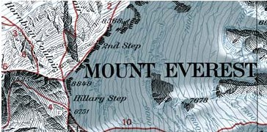
© SFAR

In addition to pursuing their mountaineering objectives, all these expeditions also carried out scientific research. They produced more than 200 monographs, over a dozen topographical maps - most of which can still be bought today - not to mention Mountains of the World, a 17-volume series published between 1946 and 1969. These publications provide eloquent testimony to the achievements of the research these expeditions carried out in the fields of mountaineering, archaeology, biology, ethnology, geography and medicine.

In the 1960s - in accordance with its founding principles - the SFAR began to expand the scope of its research
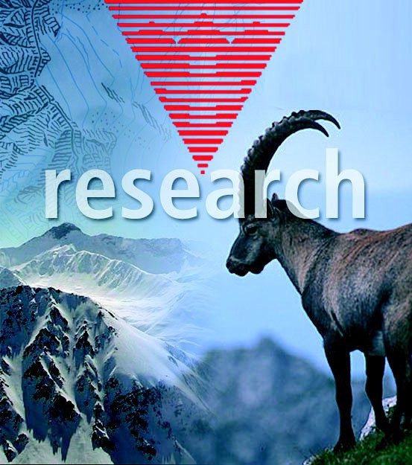
work to encompass issues relating to the preservation of nature and the protection of the environment. One example of this was its research on the alpine ibex, the Animal of the Year in 2006, which made a significant contribution to the general understanding of the areas to which the species has been reintroduced.

© SFAR
In addition, the Foundation continued its work in its main field of activity, research for the benefit of mountaineers, through its projects in cartography and high-altitude medicine.

The Foundation today
In recent years, the Foundation has focused greater attention on the rapid changes taking place in the alpine region and the effect these are having on man and nature alike.
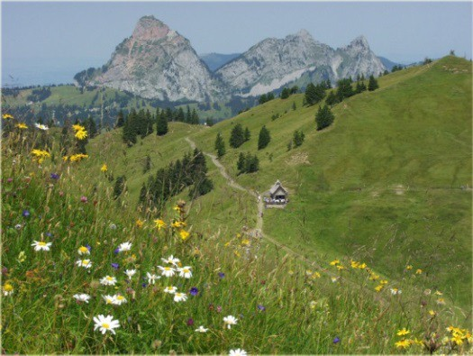

© edlibaer.ch

One imminent threat is that of entire valley areas becoming depopulated, with the result that cultivated alpine landscapes are left fallow and subject to natural reafforestation. Another danger is that intensive farming in the most viable areas will result in the most biodiverse environments, such as those found in alpine dry meadows, losing many of the species of flora and fauna they support today.
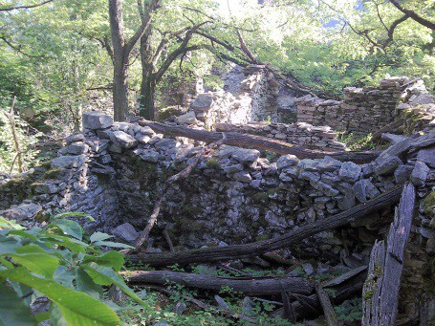
Maia, Centovalli, in the Swiss canton of Ticino © TWeber 2010
One third of all the species of alpine flora and fauna depend on cultivated mountainous landscapes for their survival. That biodiversity is now under direct threat on two fronts: an uncontrolled return to nature in some areas and the unrestrained expansion of intensive agriculture in others. The SSAF supports research projects and practical initiatives which enable the cultivated landscape to be managed in ways which are both ecologically responsible and economically sustainable. By raising public awareness of the issues involved, the SSAF aims to gain greater mainstream support for a holistic approach which will foster biodiversity in all alpine environments, whether cultivated by man or left to the forces of nature.

What we aim to achieve:

the Pro Montes Prize

© SFAR

A prize awarded to young research scientists for projects aimed at securing the future of the cultivated alpine environment
The SSAF's Pro Montes Prize was first awarded on June 6, 2012, at the Phil.Alp conference hosted in Thun by ICAS, the Inter-Academic Commission
for Alpine Research.

This first award was made to Aline Andrey, for the doctoral dissertation she wrote at the University of Bern's Institute of Ecology and Evolution. The subject of her dissertation, which was written in French, was the short-term effects of fertilisation and irrigation on biodiversity in sub-alpine meadows ("Effets à court terme de la fertilisation et de l'irrigation sur la biodiversité des prairies de fauches en milieu subalpin"). Her research disproved current general teaching on this matter by demonstrating that, far from giving rise to monocultural rich pastureland, treating these landscapes with a combination of limited quantities of manure and irrigation in fact enables them to develop into flowering meadows supporting a wider variety of flora and fauna.

The result is thus alpine biodiversity,
rather than alpine monotony!

One third of all the species of flora and fauna found in Switzerland's mountains depend for their survival on the heat and light provided by the centuries-old treeless habitats which mankind has created in the alpine regions. It is therefore vitally important to encourage and support research aimed at finding new ways of securing a future for this man-made alpine landscape which are also harmonious with efforts to protect the natural, uncultivated environment. The Pro Montes Prize, a cash prize of 2,000 Swiss francs awarded every two years, rewards outstanding research work by a young research scientist (under 35). Its purpose is to make a significant contribution to ensuring a viable future for the alpine landscape that has been shaped by man.

Current and completed projects

Ice Age Glacier Map
This map, based on the most recent findings in the field of glaciology, depicts the maximum extent to which glaciers covered the Earth's surface during the last Ice Age, some 18,000 years ago. The Foundation helped to fund this publication, which Professor Christian Schlüchter of the University of Bern prepared on behalf of the Swiss Academy of Natural Sciences' Commission for Quaternary Research.

Climate evolution in the (Swiss) alpine region over the last 10,000 years
The second publication by Professor Schlüchter supported by the SFAR used pieces of wood exposed as a result of glacier melting to demonstrate that, during several periods over the last 10,000 years, the alpine glaciers in large areas of the Alps were significantly smaller than they are today and that the treeline was higher than its current level.
The Steilimi glacier on the Sustenpass
today and 2,000 years ago
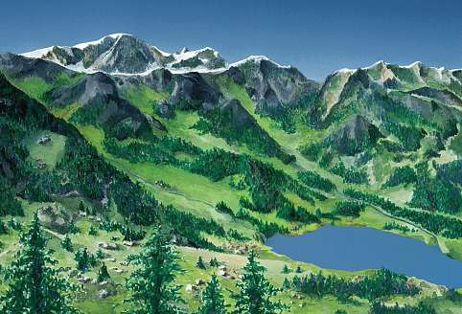
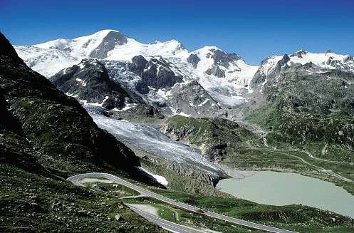
© Die Alpen/Daniel Anker © Die Alpen/Thomas Richner; Chr. Schlüchter

The alpFUTUR ÄlplerInnen project
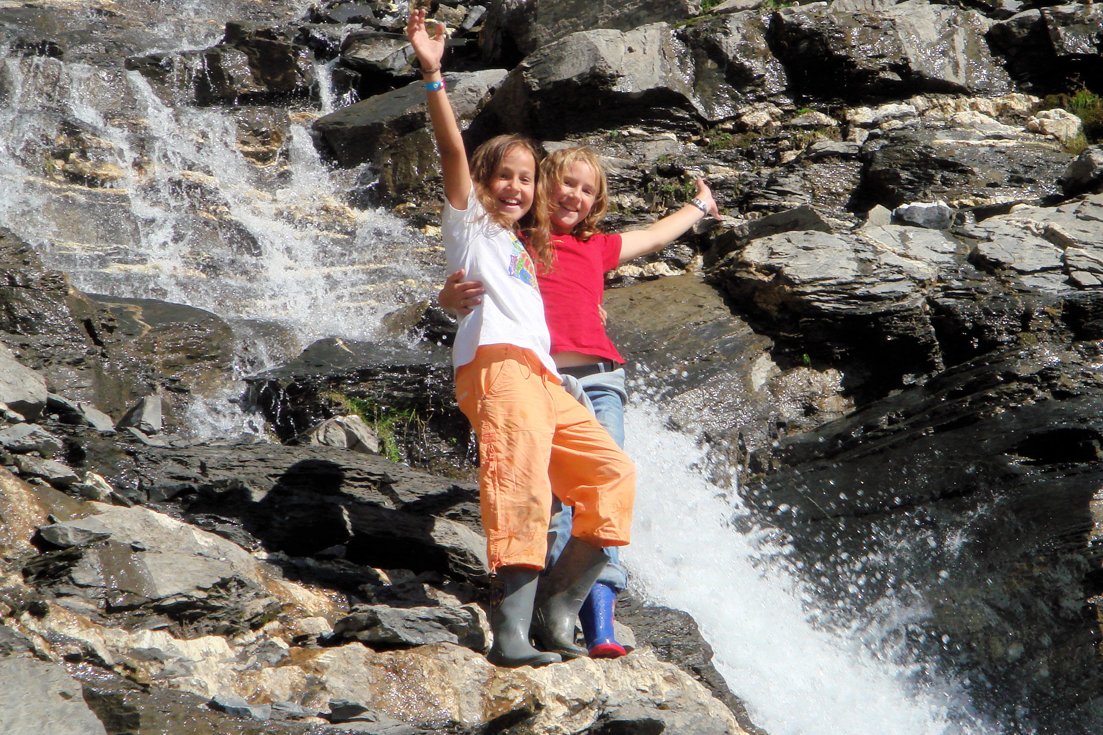
As part of the alpFUTUR.ch collaborative project, the ÄlplerInnen sub-project (the German word "ÄlplerInnen" designates men and women farming in the alps) aims to identify the key elements required to make the alpine summer pastures an attractive place to work. The SFAR decided to support this project,
© SFAR
because it is convinced that preserving alpine summer grazing pastures not only fosters mountain-specific occupations, but
also helps to ensure that the numerous species of alpine flora and fauna that depend for their survival on mountain landscapes cultivated by man are saved from extinction as a result of the reafforestation which would naturally occur if these pastures were to be left fallow.

Contact

Schweizerische Stiftung für Alpine Forschung SSAF
Fondation Suisse pour Recherches Alpines FSRA Fondazione Svizzera per Ricerche Alpine FSRA
Swiss Foundation for Alpine Research SFAR

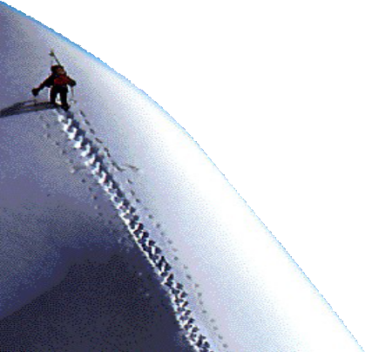
Stadelhoferstrasse 42 CH-8001 Zurich, Switzerland
Phone: +41 44 253 12 00
Fax:+41 44 253 12 01

E-mail: mail@alpinfo.ch

Website: www.alpinfo.ch

The Foundation currently has 12 different maps,
7 books and 2 DVDs which can be ordered from its website.

Donations to the Foundation's Swiss post-cheque account, 80-17493-2 (including donations of amounts from CHF 50.- upwards for those wishing to become patrons of the Foundation) are always most welcome.

We guarantee that any donations and patron contributions we receive will be used exclusively to fund our research projects.

Thomas Weber
Executive Secretary, responsible for the 2014 flyer

